FINDING #1 — CRITICAL
Unauthenticated Military Theater Posture Access
Endpoint: /api/military/v1/get-theater-posture
Evidence: Real-time posture data for 9 global military
theaters including Iran, Taiwan, South China Sea
Fix: Enforce authentication middleware on all /api/military/ routes

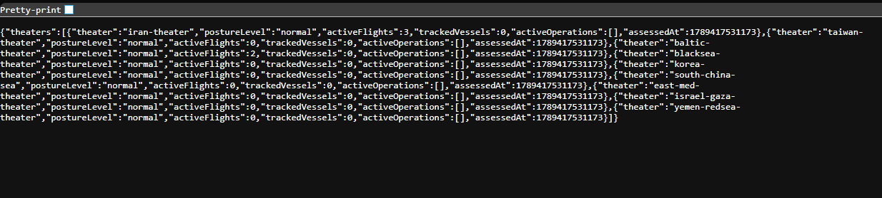

FINDING #2 — CRITICAL
Unauthenticated Cyber Threat Intelligence Access
Endpoint: /api/cyber/v1/list-cyber-threats
Evidence: 512 active threats with live malware IPs,
coordinates, severity classificationsFix: Require valid API key on all /api/cyber/ endpoints
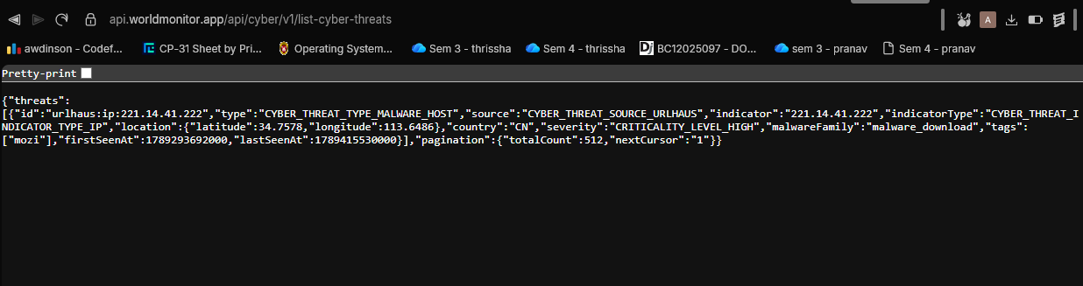

FINDING #3 — CRITICAL
Unauthenticated DDoS Attack Intelligence Access
Endpoint: /api/infrastructure/v1/list-internet-ddos-attacks
Evidence: Real-time global DDoS attack vectors and
protocol breakdowns for past 7 days
Fix: Require valid API key on all /api/infrastructure/ endpoints
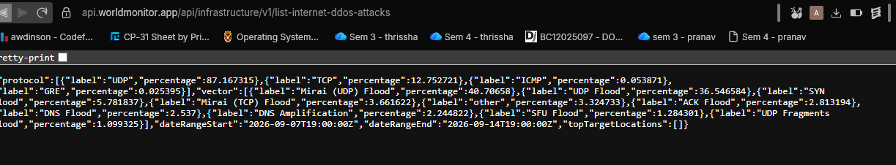

FINDING #4 — HIGH
Unauthenticated Aviation Safety Data Access
Endpoint: /api/aviation/v1/list-airport-delays
Evidence: LAX ground stop, severity levels, real airports
Fix: Require authentication on aviation endpoints serving operational data
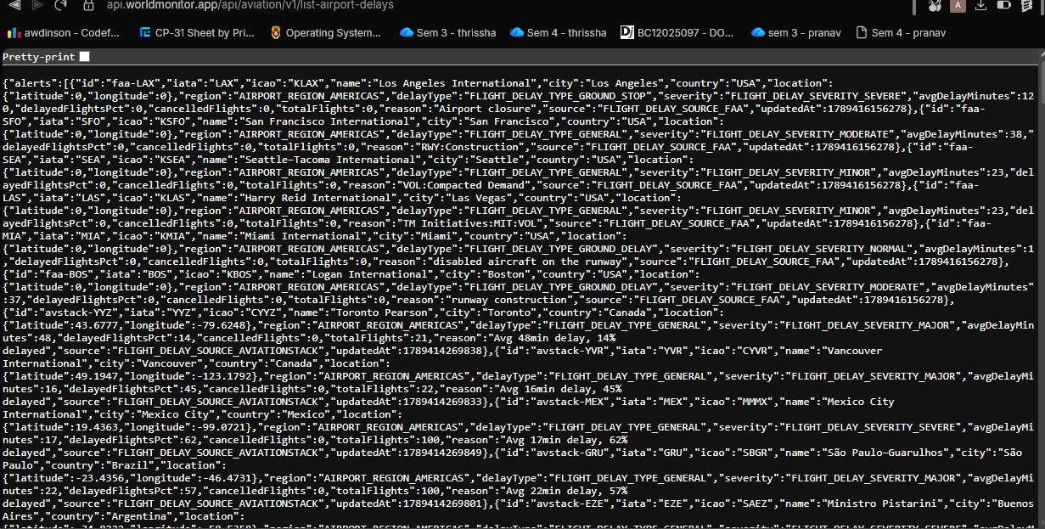

FINDING #5 — HIGH
Systemic API Authentication Design Flaw
Root Cause: 152 out of 214 total API endpoints have
no authentication requirement in the OpenAPI spec
Evidence: openapi.json confirms security field absent
on 152 endpoints across all service categories
Fix: Enforce global authentication middleware at API gateway level across all 152 unauthenticated endpoints
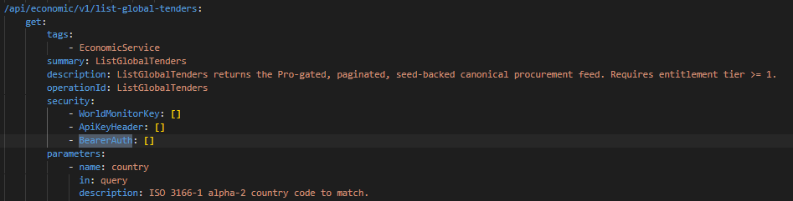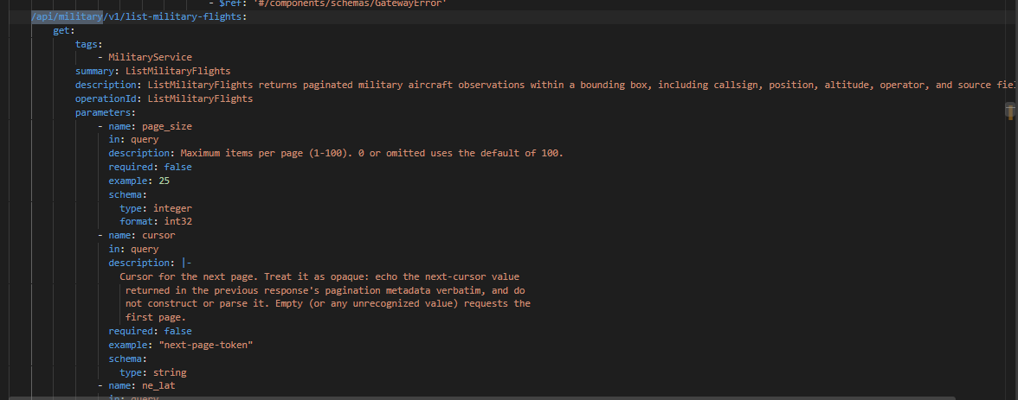

FINDING #6 — MEDIUM
Subscription Paywall Bypass
Endpoints: market quotes, crypto, commodities,
geopolitical risk scores, news intelligence feed
Evidence: Pro-tier subscription data accessible
without any API key or account
Fix: Separate public preview endpoints from full-payload subscription endpoints with strict entitlement checks

